Kaiser Stand Bracket
Version 1.0
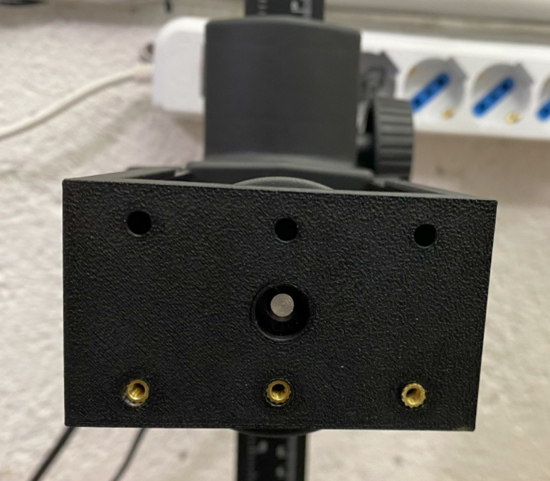

Project Goals
Create an easy to install and easy to remove bracket for Kaiser Stand, with a bunch of fixing positions created using M3 Heat Set Inserts

Sketch
Holes are on a rectangle 50 x 30 mm
I use Heat Set Inserts so the thread is M3

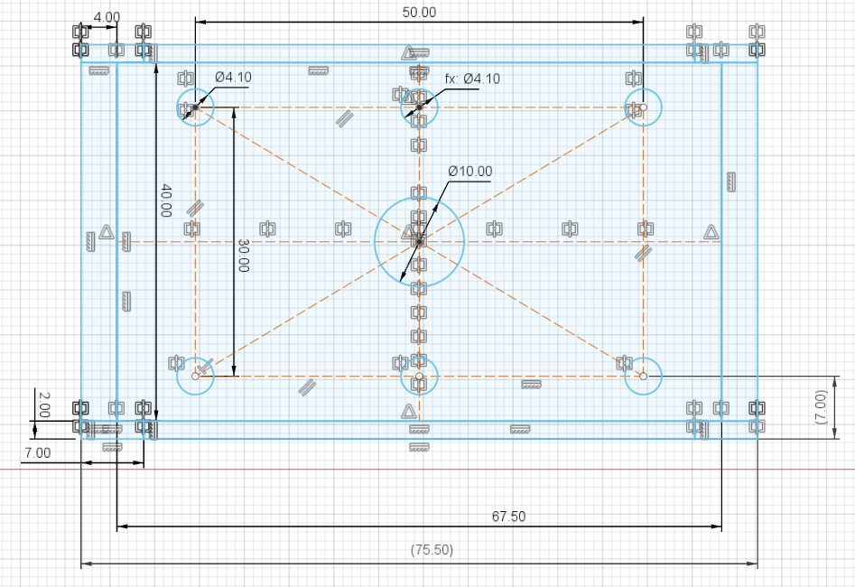

3D Models
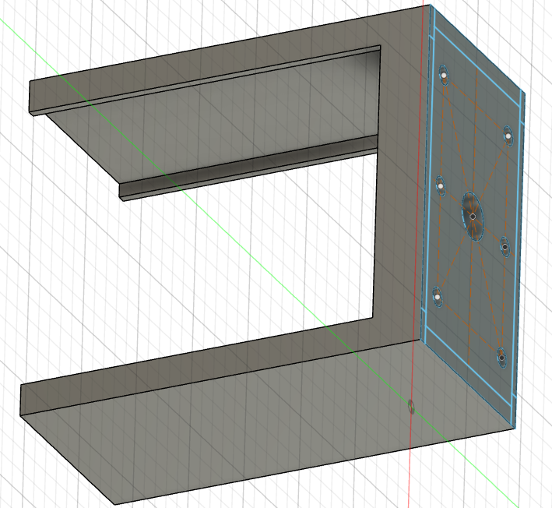

3D Printer Layout
PLA Printing time: 1h 12 m
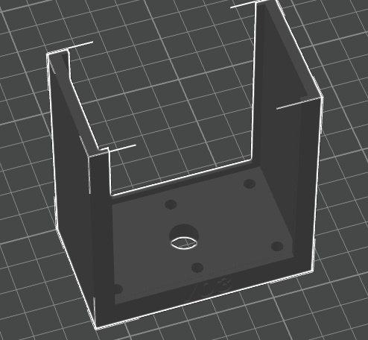

Final Result
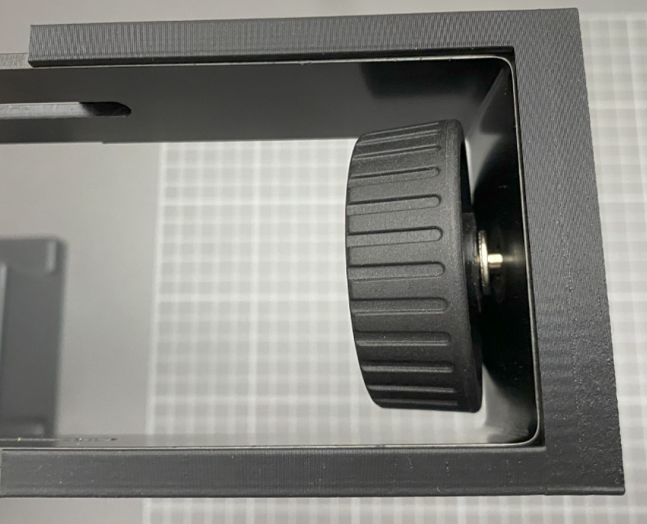 | 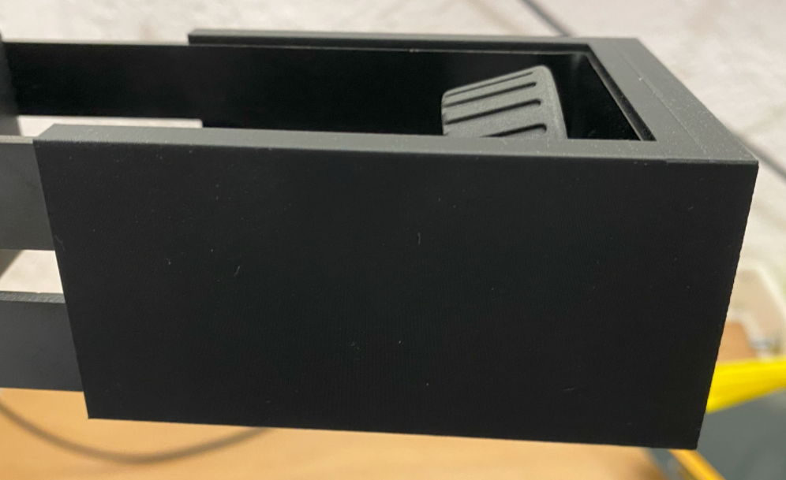
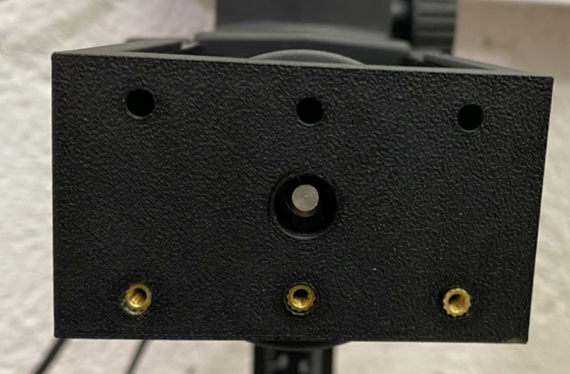

For the next Iteration
Add 4 holes for M3 insert on the side of the bracket using the thickness of the head
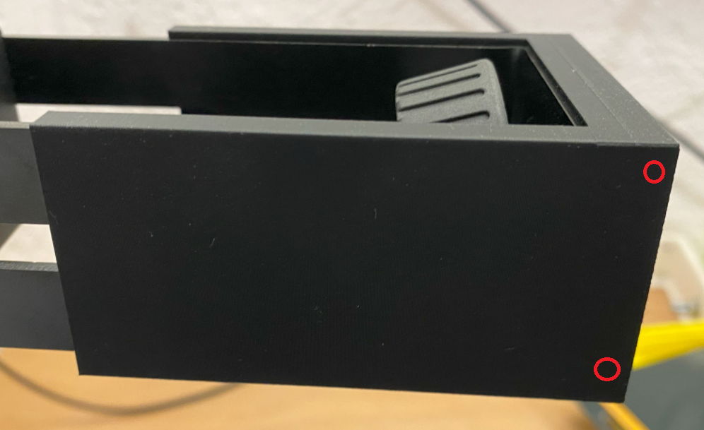

Add numbers to specify mounting distance
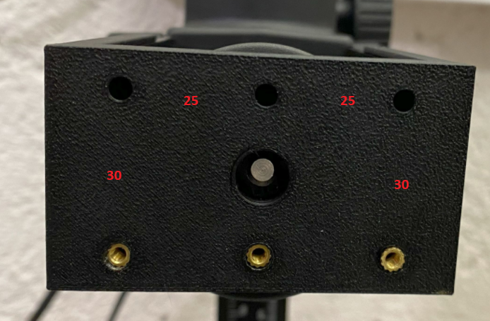

Reference

M3 Heat set insert
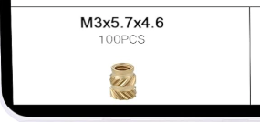
https://amzn.eu/d/2jmdR2e
